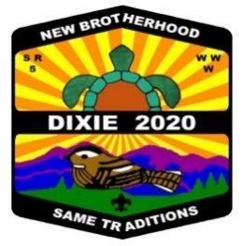
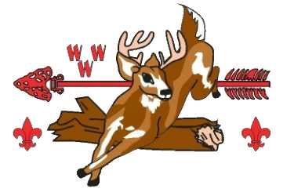
UNALI’YI LODGE 236
2020 DIXIE FELLOWSHIP REGISTRATION

The 2020 SR-5 Dixie Fellowship will be held on the weekend of April 24 - 26, 2020 at Camp Old Indian, Travelers Rest, SC. The address for Camp Old Indian is 601 Callahan Mountain Road, Travelers Rest, SC 29690. The theme this year will be “New Brotherhood Same Traditions.” Our lodge theme is the “Dixie Derby” Nascar Theme. Please bring any accessories you have. Don’t miss out on the chance to compete and cheer on your brothers in a weekend of fun filled events.

The Unali’Yi Lodge delegate fee for this year’s Dixie Fellowship will be $65.00 for adults and $60.00 for youth. The fee includes section delegate fee, all meals, programs, delegate patch, BSA Insurance and Dixie pin. Unali’Yi items include a Spirit T shirt, ONE SET OF Dixie Lodge flaps, spirit item, and dinner Friday night in our campsite between 6:00-6:30 PM. Registrations and pre orders received after January 25, 2020 are not guaranteed. There is no guarantee that there will be any extra items for sale during the event. You must pre-register to attend this event. Onsite registration is not available. Online registration and payment for Dixie is available. Check Lodge Website for Details at www.site236.com

Along with the pre-registration form, each attendee is responsible for filling out and turning in a current BSA “Annual Health and Medical Record” parts A and B. A doctor’s examination is not required. Please turn in your completed Med Form when turning in your registration. This form is available on the Lodge website. Participants must be registered with the BSA and be a member in good standing of Unali’Yi Lodge (Dues paid for 2020). All registrations are subject to the approval of the Lodge Key 3. Anyone may pre-order Dixie items whether attending or not. If you will not be present, you must make arrangements for someone to pick up your order at the Dixie Fellowship. (Please indicate who will pick up your order prior to our arrival at Camp Old Indian). The only way to be sure and get the items you want is to preorder them.

There is limited power in campsites. Those requiring CPAP machines should plan to use batteries or plan for alternate sleeping arrangements. We also need to know about any special dietary needs prior to January 25, so we can communicate with the host lodge. Participants are expected to provide their own tents and chairs. PLEASE CARPOOL WITH YOUR UNIT AND CHAPTER MEMBERS.

Unali’Yi delegates are expected to participate with the Lodge contingent during the Dixie Fellowship. If you would like to be part of the one of our competition teams please contact the Lodge Ceremonies Team, Dance Team, Sing Team, or compete in Individual Dance, contact our Ceremonies or Dance Team Chairman whose number contact info is on our lodge website. The Quest Events will include Archery, Chariot Race, Fire Building, Knot-Tying Relay, Tent Pitching, Arrow/Softball Throw, Cross Country, Shotgun, Rope Throw, Canoe Race, Egg Toss, Tug-of-War, and Volleyball.

Do not let financial difficulties prevent you from attending. Any youth member in need of financial assistance to attend, please contact James Barton, Lodge Adviser, at advisor@site236.com. All requests will be kept confidential.

We encourage chapters to assist in carpooling to Dixie. We are exploring the option of renting a vehicle to assist with transportation if this becomes a need. Those riding will be asked to contribute toward the rental and transportation cost.

Please contact Wayne Barfield at waynebarfieldjr@gmail.com or call 843-817-0084 if you are willing to help with or help transportation or help judge any of the events. We are always in need of adult volunteers at this event.

Register by January 25th to reserve your spot.

Yours in Brotherhood,
To assist with pre-Dixie communication sign up for the Dixie Remind by texting @2020dixie to 81010.
Christian Blackburn
Unali’Yi Lodge Chief

2020 Dixie Registration

Name
Unit Number
Youth/Youth +(18-21)/Adult
Phone
Email
Lodge Chapter
Are you willing to help transport scouts?
Are you in need of a ride and willing to contribute to the cost of transportation?

Dixie Fellowship Merchandise | Cost | Quantity | Amount
Adult Attendee Registration | $65.00
Youth Attendee Registration | $60.00
Transportation Fee | $15.00
2020 Unali’Yi Lodge Dues | $18.00
LODGE SPIRIT SHIRT | INCLUDED | 1 | My Size is _______
Extra Lodge Spirit T –Shirt (Size S, M, L, XL, XXL, XXXL) | $15.00
Extra Unali’Yi Patch Set | $12.00
Extra Dixie Delegate Patch | $4.00
Ghost Patch | $4.00
Neckerchief | $15.00
Back Patch | $15.00
Chenille | $25.00
Hat Pin | $4.00
Mug | $9.00
Hat | $14.00
Dixie T-Shirt (S-XL) | $14.00
Dixie T-Shirt( 2XL-5XL) | $16.00
 |  |  | Total Due=$

Online registration and payment for Dixie is available. Check Lodge Website for Details at www.site236.com

