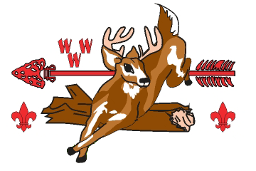
UNALI’YI LODGE
2023 Spring Fellowship

Dear Brothers,

Thank you for all your help with making Cornerstone Conclave a success. The weekend of May 19 - 21, 2023, Unali’Yi Lodge will be holding our Spring Fellowship. Check-in will be at the Trading Post from 5:00 - 7:30 pm. Please come in your full field uniform (Class A and sash) for check-in. All participants will be given a wristband at check-in, so that we can be in compliance with NCAP guidelines.

We will kick off Friday night with an opening show, followed by activities and a cracker barrel. Saturday, we will have some informative training and lots of fun activities and games including a skeet shoot, a pool party, and a BBQ cookout for lunch with yard games and music. We will wrap up the evening with an 80th Anniversary Banquet to celebrate all of the accomplishments of the 2023 Cornerstone Conclave and hold a special patch auction. We will have a NOAC planning meeting during Fellowship and discuss upcoming events for the rest of the year. Sunday morning we will have Chapel and a General Lodge Meeting where we will swear in the 2023-2024 Lodge Officers. The following arrowmen will serve as lodge officers this year:
- Lincoln Shirey - Lodge Chief
- Dora Bendetti - Vice Chief of Administration
- Quinn Dennie - Vice Chief of Program
- Ryan Barnard - Secretary
- Ayden Hudson - Treasurer

I look forward to seeing you at Spring Fellowship!

Yours in WWW,
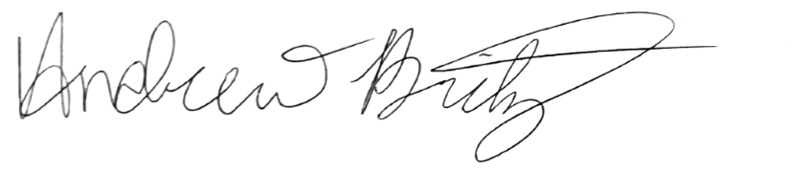
Andrew Britz
Unali’Yi Lodge Chief/ Chief@site236.com

Mark your calendar for upcoming Unali’Yi Lodge Functions:
Calendar Dates
2023 Lodge Leadership Development August 25-27, 2023 Camp Ho Non Wah
2023 Fall Ordeal September 8-10, 2023 Camp Ho Non Wah
2023 Cub Haunted October 20-22, 2023 Camp Ho Non Wah
2023 Fall Fellowship December 1-3, 2023 Camp Ho Non Wah
2024 Cornerstone Conclave April 26-28, 2024 Camp Belk (More info to follow)
2024 NOAC July 2024 University of Colorado, Bolder
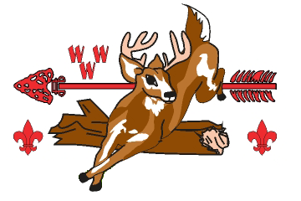
Unali’Yi Lodge 236
Spring Fellowship – May 19 - 21, 2023
Lodge Member Registration Form

PLEASE PRINT
Name ____________________________________________ Chapter/District ___________________
Address ________________________________________ City, State, Zip ____________________

Home Unit # ________ O/B/V _______________ Youth/Adult ______________________

____ Medical Concerns (Please specify on the back of this registration from)
____ I would like to seal my membership by completing Brotherhood candidacy at this function

Early Bird Registration (Prior to 5/12) Quantity Cost Total

Lodge Member - Early Bird _______ $15.00 __________

Member Registration (After 5/12) Quantity Cost Total

Lodge Member _______ $25.00 __________

DUES for 2023 _______ $18.00 __________

Total Amount Enclosed ________
Please make checks payable to BSA.
Mail to: Coastal Carolina Council, 9297 Medical Plaza Dr, North Charleston, SC 29406

Parent Consent
I hereby give my child, __________________________, permission to attend the Spring Fellowship at Camp Ho Non Wah the weekend of May 19-21, 2023. My child will stay at camp until departure on Sunday unless the Lodge Advisor is otherwise notified in writing prior to the function.
____________________________________ _____________________
Signature Date

For Office Use Only | ________________ ____________ ____________ ___________________________  Received By Date Invoice # Recorded by Lodge

